Muhammad Tanzil-Ur-Rehman

BCS211037

Lab 01

Task 01

.model small

.data

msg db " *",0Dh,0Ah,"$"

msg1 db " **",0Dh,0Ah,"$"

msg2 db " ***",0Dh,0Ah,"$"

msg3 db " ****",0Dh,0Ah,"$"

msg4 db " *****",0Dh,0Ah,"$"

.code

main:

;print strings

mov ax,@data

mov ds,ax

mov ah,9

mov dx, offset msg

int 21h

mov ah,9

mov dx, offset msg1

int 21h

mov ah,9

mov dx, offset msg2

int 21h

mov ah,9

mov dx, offset msg3

int 21h

mov ah,9

mov dx, offset msg4

int 21h

mov ah,4ch

int 21h

end main

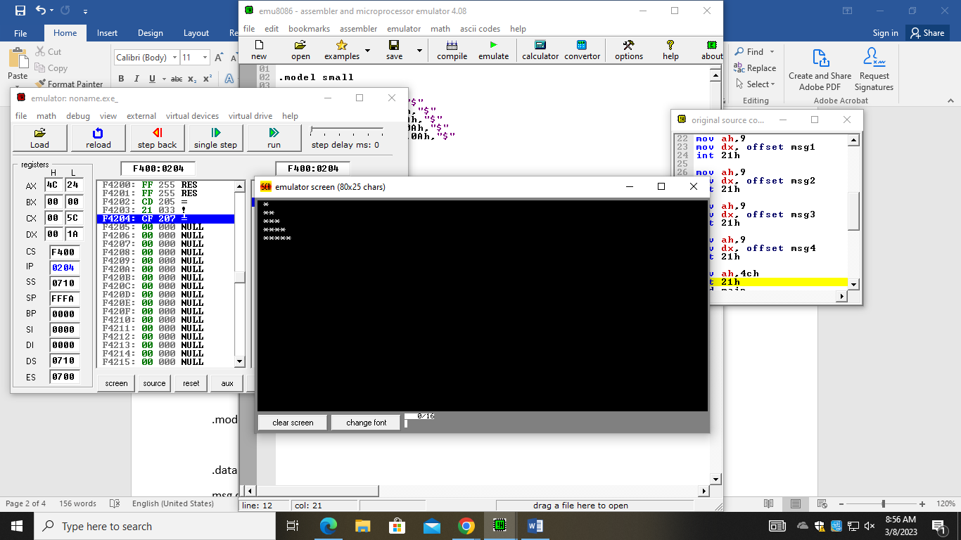

Task 02

.model small

.data

msg db "This ",0Ah," $"

msg1 db "is",0Ah," $"

msg2 db "my",0Ah," $"

msg3 db "name ",0Ah," $"

.code

main:

;storing string data

mov ax,@data

mov ds,ax

;print strings

mov ah,9

mov dx, offset msg

int 21h

mov ah,9

mov dx, offset msg1

int 21h

mov ah,9

mov dx, offset msg2

int 21h

mov ah,9

mov dx, offset msg3

int 21h

mov ah,4ch

int 21h

end main

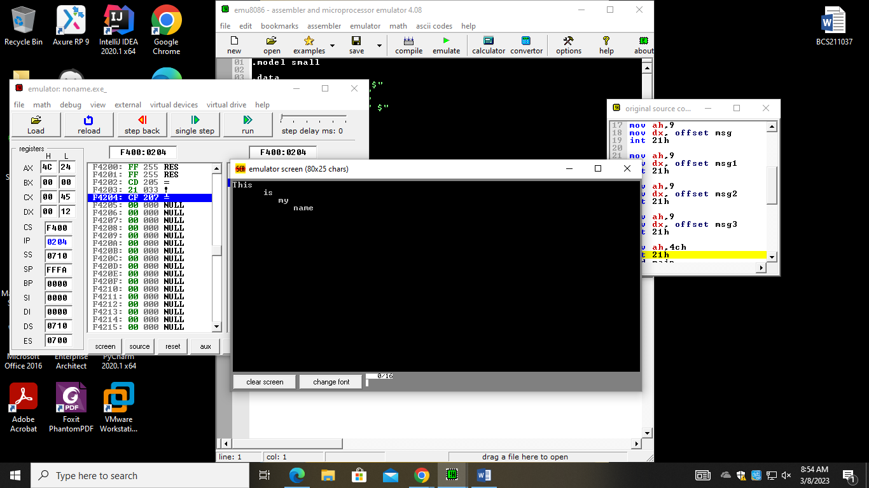

**Task 3**

.model small

.data

msg db " * ************ * *",0Dh,0Ah,"$"

msg1 db " ** *********** ** **",0Dh,0Ah,"$"

msg2 db " *** ********** *** ***",0Dh,0Ah,"$"

msg3 db " **** ********* **** ****",0Dh,0Ah,"$"

msg4 db " ***** ******** ***** *****",0Dh,0Ah,"$"

msg5 db " ****** ******* ****** ******",0Dh,0Ah,"$"

msg6 db " ******* ****** ******* *******",0Dh,0Ah,"$"

msg7 db " ******** ***** ******** ********",0Dh,0Ah,"$"

msg8 db " ********* **** ********* *********",0Dh,0Ah,"$"

msg9 db " ********** *** ********** **********",0Dh,0Ah,"$"

msg10 db " *********** ** *********** ***********",0Dh,0Ah,"$"

msg11 db " ************ * ************ ************",0Dh,0Ah,"$"

.code

main:

;moving data in the register

mov ax,@data

mov ds,ax

mov ah,9

mov dx, offset msg

int 21h

mov ah,9

mov dx, offset msg1

int 21h

mov ah,9

mov dx, offset msg2

int 21h

mov ah,9

mov dx, offset msg3

int 21h

mov ah,9

mov dx, offset msg4

int 21h

mov ah,9

mov dx, offset msg5

int 21h

mov ah,9

mov dx, offset msg6

int 21h

mov ah,9

mov dx, offset msg7

int 21h

mov ah,9

mov dx, offset msg8

int 21h

mov ah,9

mov dx, offset msg9

int 21h

mov ah,9

mov dx, offset msg10

int 21h

mov ah,9

mov dx, offset msg11

int 21h

mov ah,4ch

int 21h

end main

